Room A
AQ1 APPENDICEAL CARCINOID
Stem: A previously healthy 68-year-old woman is seen in the ED, reports 18 hours of RLQ abdominal pain and CT findings showing acute appendicitis without perforation, abscess, or phlegmon. The patient has no contraindications to surgery.
What would you like to do now?
Laparoscopic or Open Appendectomy (Describe)
Path Returns with 6mm well circumscribed carcinoid tumor near tip of appendix with no lymphovascular invasion or evidence of perforation. Patient asks what she will have to get done for that?
Nothing further
What if: Path Returns with 14mm well carcinoid tumor at mid appendix with lymphovascular invasion?
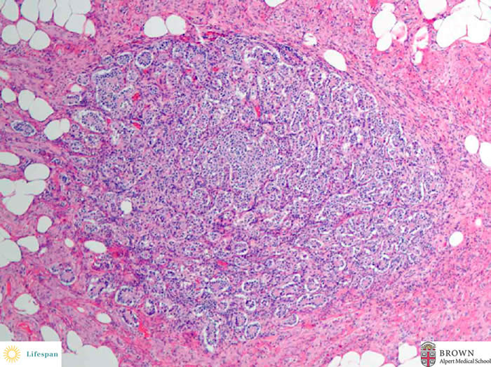

What would you do now ?
- PET-Dotatate or Octreotide scan post op, with tumor markers
- Right Colectomy (Describe)
What if: Path Returns with 34mm well-circumscribed carcinoid tumor at mid appendix without evidence of perforation or lymphovascular invasion.
- Right colectomy
Describe:
- Open, laparoscopic, or Robotic.
- Identify ileocolic vessel.
- Lateral to medial or medial to lateral mobilization
- High ligation of the ileocolic vessel.
- Take omentum of the transverse colon.
- Distal and proximal transection.
- Anastomosis.
Scenario: At the time of surgery an approximately 18mm tumor is palpated during an appendectomy near the tip of the appendix after opening the appendix on the back table because of the firm palpable mass. Frozen specimen returns with likely carcinoid tumor.
1. No further surgery required.
Frozen pathology returns with adenocarcinoma:
1. Right colectomy
Scenario: There is a mucinous mass involving the base of the appendix. During mobilization and right colectomy there is spillage of mucin. What next?
- referral for evaluation for HIPEC. Decision to HIPEC will be based on serial imaging, pathology (benign vs. adenocarcinoma).
- if during appendectomy for mucinous mass there is evidence of mucin spillage consider peritoneal lavage/cytology
- Pitfalls:
- Inability to describe right colectomy.
- Not knowing appropriate surgical procedure
- Not recognizing when to refer to HIPEC.
References:
- Muñoz de Nova JL, Hernando J, Sampedro Núñez M, et al. Management of incidentally discovered appendiceal neuroendocrine tumors after an appendicectomy. World J Gastroenterol. 2022;28(13):1304-1314. doi:10.3748/wjg.v28.i13.1304.
- https://www.nccn.org/professionals/physician_gls/pdf/neuroendocrine.pdf

AQ2 Melanoma
Stem: A 40-year-old male presents with a pigmented lesion on his right lower extremity. First noticed it three months ago, denies recent changes in the appearance of the lesion. He uses sunscreen sporadically and recalls having sunburns as a teenager.
His medical and surgical history are unremarkable.
He denies a personal or family history of skin cancer.
Physical exam reveals this.

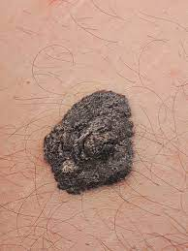

What is your differential diagnosis?
- Melanoma
- Melanocytic nevus
- Basal cell carcinoma
- Seborrhoeic keratosis
- Dermatofibroma

What would you like to do now?
- Complete skin exam evaluating for additional suspicious lesions, regional lymph node exam.
- Biopsy

Biopsy returns as melanoma, Breslow depth 1.2mm with no evidence of ulceration, mitotic rate < 1 mitosis/mm² (T2a)

What is Next?
Wide local excision and SLNB w/ margins of 1.0 to 2.0mm
Order immunohistochemistry for nodes (BRAF, S100)

Pathology returns as residual melanoma, Breslow depth 1.2mm, negative margins, 2 of 3 nodes positive for metastatic disease.
- Stage w/ PET CT
- Completion lymph node dissection (CLND) VS active nodal surveillance w/ ultrasound.

What’s the risks and benefits of both?
- Risk of lymphedema higher in CLND (24%) vs surveillance (6%)

Patient elects CLND, What’s now?
Inguinal lymph node dissection:
  - Skin incision between the anterior superior iliac spine and pubic tubercle
  - 8 cm in length, and 2 cm below and parallel to the inguinal ligament.
  - Identify Camper’s fascia.
  - Mobilize the fibrofatty tissue under Scarpa’s fascia
  - Continue until you reach the inguinal ligament (upper border of the dissection).
- Dissect the superficial inguinal lymph nodes off the inguinal ligament down to the femoral triangle.
- Separating the groin nodes off the femoral triangle floor.

Patient selects active nodal surveillance, what is the recommended follow up?
- US affected nodal basin every 4 months for 2-3 years.
- Annual PET CT
- Then every 6 months for next 2-3 years
- After 5 years, perform US annually until 10 years out from SLNB

Scenario: Another patient, referred by dermatologist for punch biopsy with Breslow depth of 0.7mm, no ulceration

1. Wide local excision with 1.0mm margins, no SLNB

Scenario 4: Same patient but has a firm, palpable lymph node in the right groin?! Now what?! FNA

FNA : Metastatic melanoma (should not recommend excisional biopsy as it may interfere with future node dissection. How would you manage?

- Test tumor for BRAF gene mutation
- Stage w/ CT c/a/p or PET CT +/- MRI brain:
(Regional disease appears borderline respectable.)
- Refer to medical oncologist for systemic therapy.

Can you give examples?!
- Nivolumab (anti-PD-1 antibody), targeted therapy against BRAF (dabrafenib)
- Downstream target MEK (trametinib)

Patient shows good response.
Proceed with CLND

What is high risk recurrence and what would you recommend?
  - multiple nodes
  - Extracapsular extension

Consider adjuvant XRT to regional basin.

Pitfalls:
- Differential diagnosis not including Melanoma, Melanocytic nevus, Basal cell carcinoma.
- No knowledge of staging.
- Not knowing when to do CLND.
- Not knowing to consult medical oncology and treatment.
References:
  - https://emedicine.medscape.com/article/280245-guidelines#g9
  - https://www.nccn.org/professionals/physician_gls/pdf/cutaneous_melanoma.pdf

AQ3 Thoracic Vascular Injury
Stem: A 56y old male is brought by EMS to the ER with a self-inflicted GSW to the chest. He was intubated en route, has two 16g IVs in antecubital fossa and has no other signs of trauma. He lost pulses in the ambulance bay.
A left anterolateral thoracotomy is immediately performed.

Describe steps of ER Thoracotomy:
- Left arm above head, 4th interspace incision from sternum to bed with retractor handle pointed towards axilla.
- Longitudinal pericardiotomy anterior to phrenic nerve.
- Mobilize inferior pulmonary ligament.
- Manual compression of heart and/or Cross clamping of the descending aorta
- Right mainstem intubation and placement of OGT

Dark blood is noted upon pericardiotomy. Upon inspection it appears there is a laceration to the left ventricle. How would proceed?

- Extend pericardiotomy to deliver heart into the left chest.
- Temporary control with manual pressure.

If you have insufficient exposure? Convert to clamshell thoracotomy.

How do control the Hemorrhage in the trauma bay?
- Manual pressure
- Skin stapler for cardiac injuries
- Foley catheter with inflated balloon
- Inflow occlusion

Describe Inflow occlusion?
- Manual occlusion of Right atrium or manual occlusion of SVC/IVC,
- Lift heart. Effectively causes inflow occlusion.

You were able to repair, this maneuver causes the heart to arrest, how to restart?
  - Restart heart by rewarming with warm saline, cardiac message.
  - Defibrillation with internal paddles set between 10-30 joules.
  - May need to bolus bicarbonate.

How do you repair the following?
- Atrial laceration
  - Clamp with satinsky clamp and oversew the line with 3-0 prolene
If unable to control with clamp? Run it closed.

- Small ventriculotomy
Repair with interrupted 4-0 prolene sutures. (Don’t have time for pledgets)

- Laceration close to coronary artery
  - Deep horizontal mattress suture underneath coronary

- Transected coronary
If distal, tie it off. If proximal, patient is probably dead. Still tie off as
it isn’t practical to do bypass
Watch for EKG changes.

Pitfalls:
Know temporary control measures.

References :
  - https://www.east.org/education-career-development/practice-management-guidelines/details/emergency-department-thoracotomy
  - https://accesssurgery.mhmedical.com/content.aspx?sectionid=156213748&bookid=2057
  - https://emedicine.medscape.com/article/82584-overview
  - http://www.mactheknife.org/Chest_Trauma/ER_thoracotomy.html

